Thinking about a career in law?

The Mills & Reeve Ability Development Award 2023

Registration form
We want to enable and encourage young people from underrepresented communities to gain work experience and qualify as lawyers.

We take diversity and inclusion seriously. People with disabilities and long-term conditions are significantly underrepresented in the legal profession, and we have set priorities and goals to increase the proportion of these people in our workforce, as well as removing barriers for people who may not have equal opportunities to enter the legal profession.

The award
We are offering one award aimed at first- or second-year student attending university with a keen interest in law. Our award provides a student with a disability or long-term condition with some financial support, along with skills and experience which will be useful for a career in the law. This will include:
- A bursary of £1,000 to support with your studying needs
- Work experience – one week in one of our UK offices (Birmingham, Cambridge, Leeds, London, Manchester, Norwich, or Oxford)
- Sessions with a mentor to support you on your journey
Timescales
Deadline for submissions | Friday 31 March 2023
Decision made | Friday 28 April 2023
Formal notification | Friday 5 May 2023
Work experience | To be agreed

Partnership with Business Disability Forum (BDF)
In selecting the successful candidate, Mills & Reeve is delighted to be working in partnership with the Business Disability Forum (BDF). Mills & Reeve has set the criteria, and BDF and Mills & Reeve will be reviewing submissions. A team from Mills & Reeve and BDF will identify the recipient of the award.

Mills & Reeve is a member organisation of the Business Disability Forum.

Please complete the form below and return to roop.dhatt@mills-reeve.com. If you require any adjustments to the application process, please contact roop.dhatt@mills-reeve.com for a confidential discussion.

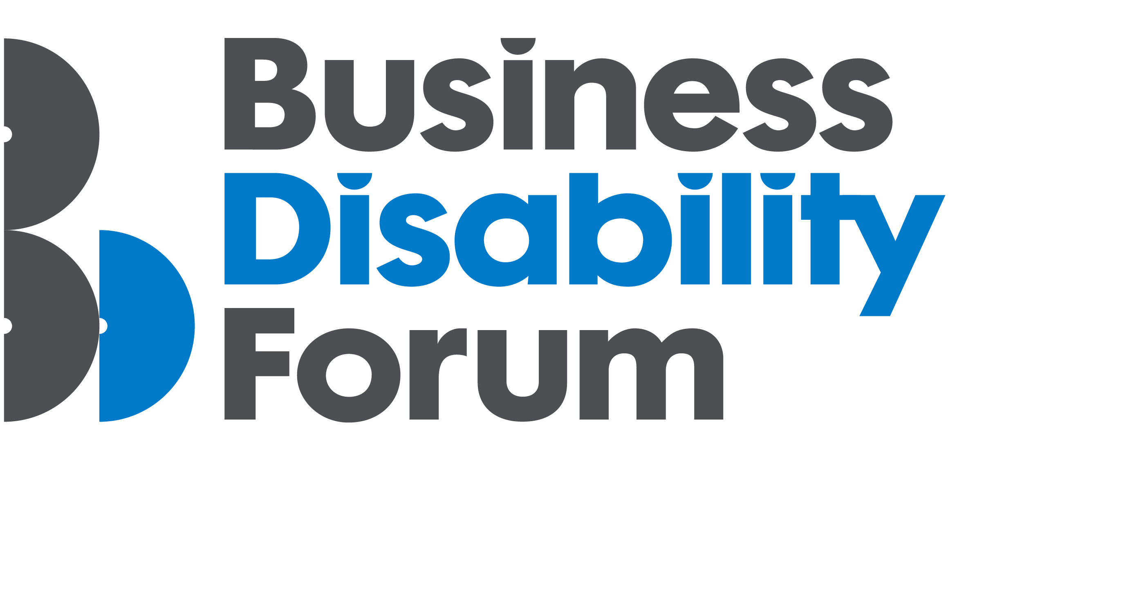
Section 1 – personal details
First name
Surname
Contact address
Mobile number
Email address
Date of birth
How did you hear about the Mills & Reeve
Ability Development Award?

Which office are you applying for?
☐ Birmingham
☐ Cambridge
☐ Leeds
☐ London
☐ Manchester
☐ Norwich
☐ Oxford

Please confirm that you are a first or second-year law student with a disability and/or long-term condition | Yes/No (delete as appropriate)

If you require any adjustments to the application process, please contact roop.dhatt@mills-reeve.com for a confidential discussion.

Section 2 – education

In January 2022, at which stage of your studies will you be?
First year
Second year
University – please state University and degree course
Other
Where did you study your A levels?
A level results

Where did you study your GCSEs?
GCSE results
Do you have any other relevant qualifications?

Please tell us about any relevant work experience that you have undertaken

Section 3 – personal statement
Please use this space to tell us more about yourself (maximum two sides of A4) – including but not limited to:
- Why would you like a career in law?
- Your biggest achievement in life so far?
- How will this award help you?
- If relevant, what obstacles have you had to overcome to get to this stage?
- Any other relevant information you would like to share to support this application

Law careers

If you were to rate your current level of awareness to the possible careers available in law, where would you score yourself?
(1 being not very aware – 5 extremely aware)

1 | 2 | 3 | 4 | 5

How confident do you feel about understanding the different routes into law?
(1 not very confident – 5 extremely confident)

1 | 2 | 3 | 4 | 5

How motivated and inspired do you currently feel about becoming a lawyer?
(1 not very – 5 extremely motivated)

1 | 2 | 3 | 4 | 5

Section 5 – equality monitoring form
(This will be detached and not used within the selection process - this is for anonymised monitoring purposes only)

Age: Prefer not to say
Gender (please tick):
Male Female  Non binary Other |  |  |  |  |  |  |  | Prefer not to say
Do you identify as trans? (please tick):
Yes |  |  | No |  |  |  |  | Prefer not to say
Sexual orientation (please tick):
Bisexual |  |  | Gay /lesbian
Heterosexual/straight |  |  | Other |  |  |  | Prefer not to say
Ethnicity (please tick):
Asian or Asian British:
Bangladeshi |  | Chinese |  |  |  | Indian
Pakistani |  | Other Asian
Black or Black British:
Black African |  | Black Caribbean |  |  |  | Other Black
Mixed Ethnicity:
White & Asian | White & Black African |  |  |  | White & Black Caribbean
Other Mixed
White:
British/English/Welsh/Scottish/N Irish |  |  |  | Gypsy or Irish Traveller |  |  |  |  | Irish
Other White

Other Ethnic Group:
Arab/Middle Eastern |  |  |  | Other Prefer not to say
Religion (please tick):
Buddhist |  |  | Christian |  |  |  |  | Hindu
Jewish |  |  | Muslim |  |  |  |  | Sikh
Other |  |  | I do not have a religion |  |  |  |  | Prefer not to say
Do you consider yourself to have a disability?
Yes |  |  | No |  |  |  |  | Prefer not to say
Social mobility (please tick)
Did you mainly attend a state or fee-paying school between 11-18: |  |  | UK State School  UK Independent/Fee-paying school  Attended school outside the UK  Prefer not to say |  |  |  |  | please state if fee paying or scholarship
Caring responsibilities
Do you have Carer Responsibilities? Yes No |  |  |  |  |  |  |  | Prefer not to say

General Data Protection Regulation (GDPR) 2018
Mills & Reeve processes data in accordance with GDPR 2018. The personal information that you provide on these forms will be processed for purposes connected to the legitimate business of the Firm and the agreed Award. Information may be shared with BDF for the purposes of agreeing the chosen recipient of the Award.

Declaration
I declare that the details given on this form are true to the best of my knowledge.

Signed:

Date:

Please send completed form to roop.dhatt@mills-reeve.com

Deadline: Friday, 31 March 2023

