Witness statement template

Set out details of employer or organisation involved
Statement of [ ] to assist the Coroner with the death of [ ]

I, [ ], am [set out details of your job or role] [address of employer or organisation]
- Personal details
  - Outline your full name, business address, occupation, position and name of your employer. Any relevant experience and qualifications you have obtained and how long you have worked for the trust. Explain when you qualified (if appropriate). Add any more relevant information about yourself and your experience and any particularly relevant experience to comment on the matters in hand. There is no need to give your home address.
- Terms of Reference
  - Explain the purpose of the statement and why you have been asked to provide it and by whom. For example, you may have been asked by the Coroner/your solicitor or legal department/solicitor/complaints manager to provide a statement to the Coroner into the death of a particular patient. You may be responding to a complaint. If you have been asked to consider any particular issues you should outline them here. If it is a factual account only which you have been asked to provide, then you should say so. Outline your understanding that the statement will be provided to the Coroner or to whoever to assist with their enquiry.
- Evidence and Methodology
  - Outline what documents and other references you have referred to in preparing the statement. Have you used any medical records, other records and documents or any personal notes? Have you spoken to any staff about the event and if so, why and on what basis? Are you relying upon your memory of events? If you can actually remember events then say so – and why. There is nothing wrong, however, in relying upon the notes you have made about a particular individual or incident, this is one reason why you might have been taught to make full and contemporaneous notes.
- Factual Outline
  - In chronological order, set out what happened when you were involved with the matter, starting from your first relevant contact and finishing with your last involvement or relevant facts you learnt afterwards. Keep your narrative short but accurate. For instance you may include the following things:
    - Why you were involved with the deceased.
    - Any specific role you may have had with management, care or liaison with the deceased.
    - What contact did you have and why?
    - If you are a health and care professional what treatment and care did you provide. What treatment the deceased received generally
    - Matters you observed when interacting with the deceased

This list is not exhaustive.
  - Include the date and time of events wherever possible making reference to any contemporaneous records or notes.
  - If you have been asked to provide answers to specific questions or to provide any comment or observations that are within your experience and expertise you should set these out clearly. You should do this in a separate section
  - Conclude your statement as follows:

“I believe that the facts stated in this statement are true. I understand that proceedings for contempt of court may be brought against anyone who makes, or causes to be made, a false statement in a document verified by a statement of truth without an honest belief in its truth”

Signed:

Dated:

Mills & Reeve on-line inquest support
You will find this guidance and a lot more information and guidance documents on our free on-line support page

There is also a set of videos with top tips on what to do and others tell their stories of who they got through the process. All designed to make it a little bit easier for you.

Follow the link or type in:
https://www.mills-reeve.com/foresight/inquests/information-on-inquests

Recent Feedback
“ I’m most grateful for your support during the Inquest. It was outstanding. ”
. Executive Director Forensic Services, NHS Client

“I feel genuinely privileged to know that you are on our team and offer my heartfelt thanks”
Dr Stephen Merron, Consultant Anaesthetist, University Hospital North Midlands NHS Trust

Contacts
Feel free to contact our inquest specialists as any time:

 | Neil Ward  Partner  for Mills & Reeve LLP  +44(0)121 456 8202  neil.ward@mills-reeve.com | 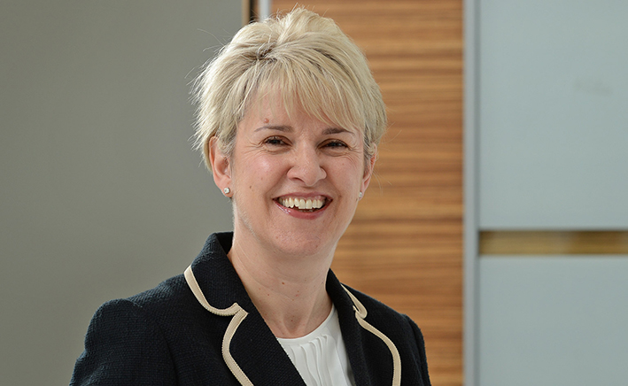 | Jill Mason  Partner and Head of Health & Care  for Mills & Reeve LLP  +44(0)121 456 8367  Jill.mason@mills-reeve.com
Duncan Astill
Partner
for Mills & Reeve LLP
+44(0)1223 222477
duncan.astill@mills-reeve.com

www.mills-reeve.com T +44(0)344 880 2666
Mills & Reeve LLP is a limited liability partnership authorised and regulated by the Solicitors Regulation Authority and registered in England and Wales with registered number OC326165. Its registered office is at 7th & 8th floors, 24 King William Street, London, EC4R 9AT, which is the London office of Mills & Reeve LLP. A list of members may be inspected at any of the LLP's offices. The term "partner" is used to refer to a member of Mills & Reeve LLP.
The contents of this document are copyright © Mills & Reeve LLP. All rights reserved. This document contains general advice and comments only and therefore specific legal advice should be taken before reliance is placed upon it in any particular circumstances. Where hyperlinks are provided to third party websites, Mills & Reeve LLP is not responsible for the content of such sites.
Mills & Reeve LLP will process your personal data in accordance with data protection and privacy laws applicable to the firm (including, as applicable: the Data Protection Act 2018, the UK GDPR and the EU GDPR). You can set your marketing preferences or unsubscribe at any time from Mills & Reeve LLP marketing communications at www.preferences.mills-reeve.com or by emailing preferences@mills-reeve.com.

